# **Project – 1**

### *7. Publish the report on Power BI cloud service and Design the Master*

### *Dashboard consisting of Funnel chart and scatter plots. Then create a schedule refresh for six times in every 4 hours for the Dashboard in a day.*

### *8. Use Q&A feature of Power BI, a) To show average age of students b) Donut chart for total amount of purchases by ‘Store location’*

*Answers(Q.7 & 8 )*

*Dashboard Created*

**Download Power BI Gateway (Download Standard Mode)**

* ***Installation of Power BI Gateway Completed***

* ***Now Click on Register New Gateway***

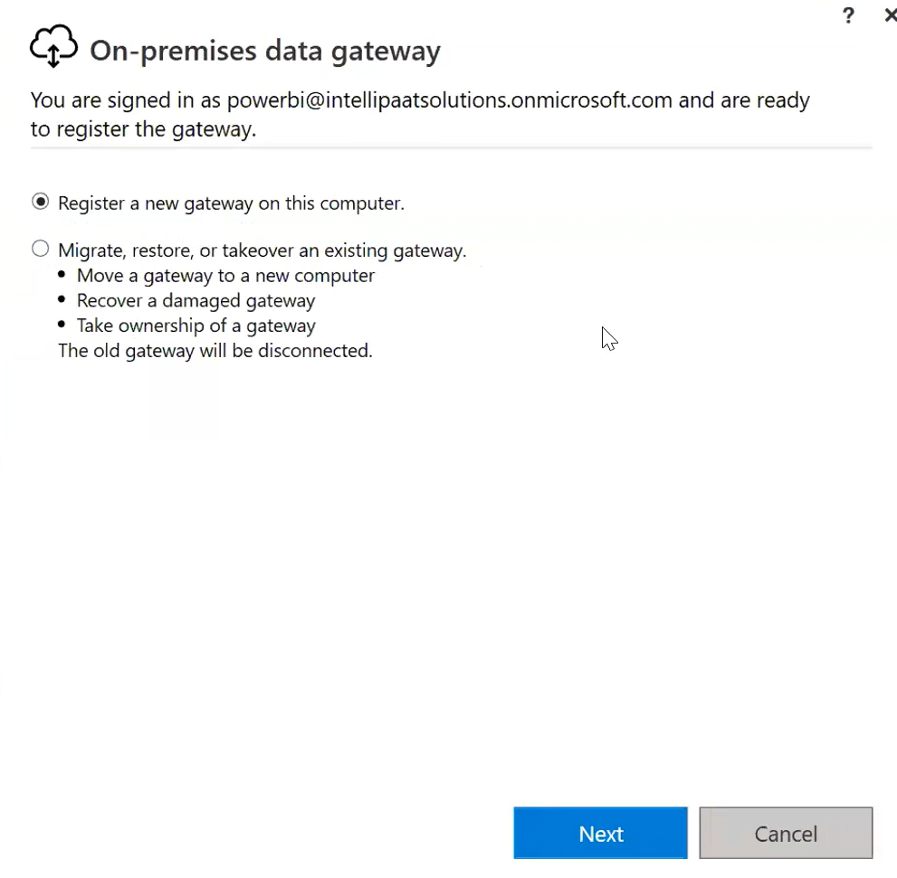

* ***Now put new On-premises Gateway name, recovery key***
* ***Now the Gateway is online & ready to use (ref. screenshot below)***

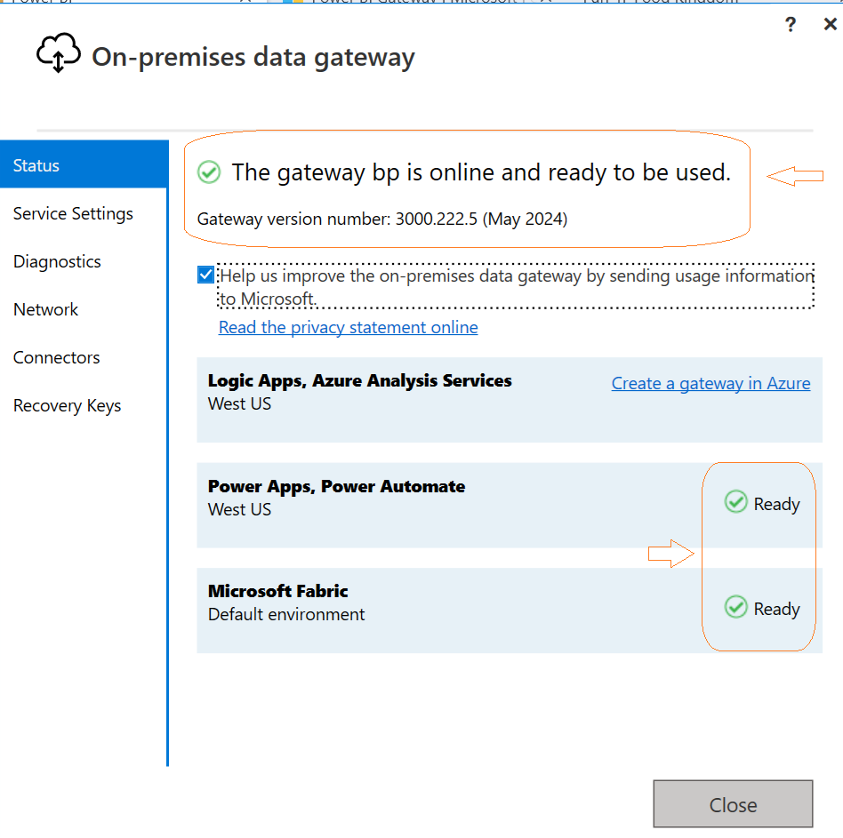

***Scheduling Refresh:***

* ***After completion of above steps, now come back to Power Service***
* ***Go to Workspaces -> Dataset (that got published) -> Schedule Refresh (refer screenshot)***

* ***Go to Gateway & Cloud Connection -> Click on button (like arrow mark)***
* ***Then click on “Add to Gateway”***

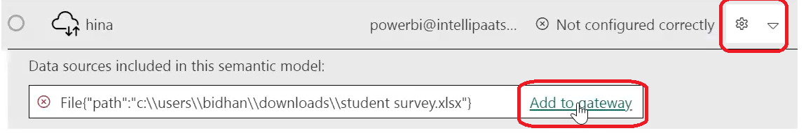

* ***Now Add the details of New Connection i.e.***
  + ***Enter your system name as User name***
  + ***Window password (as desired)***
  + ***Skip Test Connection***
  + ***Privacy Level “Organizational”***

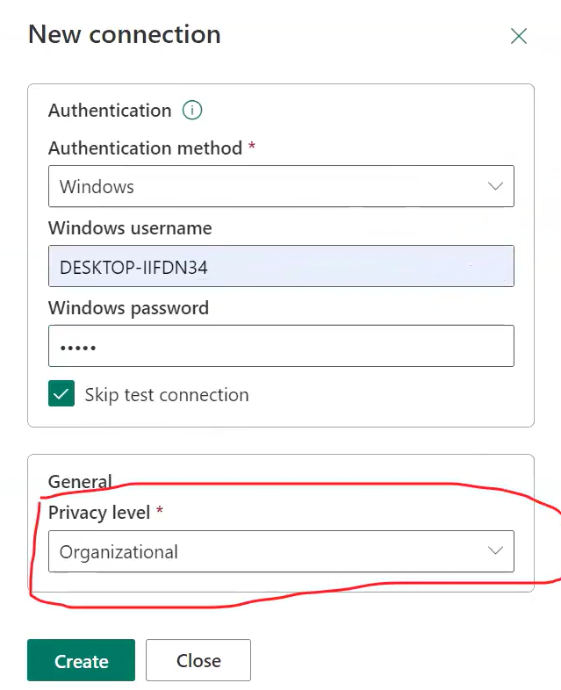

* ***Once Connection is established, now map to Gateway and click on Apply***

***Now Scheduling Refresh For 6 Times in every 4 hours (as per Question no. 7)***

